SIMATS ENGINEERING
ASSESSMENT TOOL 2

NAME: B. Sai Manoj Kumar
Reg No: 192411251
COURSE NAME: INTERNET PROGRAMMING
COURSE CODE: CSA43

COURSE OUTCOME COVERED

CO -2 : Apply CSS layout and styling techniques to create visually appealing and responsive web interfaces, and use JavaScript to enable interactive client-side behavior. (L3)

Assessment Tool : Design Task

Weightage: 20%

QUESTIONS: Total Marks: 20

Question 1: Responsive Navigation Bar Design - Marks(4)
Suppose that an e-commerce website requires a responsive navigation bar that adapts across desktop, tablet, and mobile devices.
(a) Identify key components required in a navigation bar for an e-commerce website.
(b) Design a responsive navigation bar using appropriate CSS techniques.
(c) Demonstrate how the navigation adapts to smaller screens (e.g., hamburger menu).
(d) Evaluate the usability and suggest improvements for better user experience.

ANS:
(a) Key components required in an e-commerce navigation bar
A responsive e-commerce navigation bar should include:
- Website logo or brand name
- Home link
- Products/Categories menu
- Offers or Deals section
- Cart icon
- Search bar
- User account/login option
- Responsive menu (hamburger icon) for mobile devices
These components help users easily navigate the website and access important shopping features.
(b) Design a responsive navigation bar using CSS
The navigation bar can be created using CSS Flexbox.
Features:
- display: flex for horizontal alignment
- justify-content: space-between for proper spacing
- align-items: center for vertical alignment
- padding and gap for consistent spacing
- Background color and hover effects for better appearance
(c) Demonstrate adaptation to smaller screens
For tablet and mobile screens:
- Navigation links are hidden.
- A hamburger menu icon is displayed.
- Clicking the hamburger icon shows the navigation links vertically.
- Media queries (max-width: 768px) are used to change the layout.
This ensures the navigation remains usable on small screens.
(d) Evaluate usability and suggest improvements
Advantages
- Easy navigation on all devices
- Better screen space utilization
- Mobile-friendly design
- Improved readability
Suggested improvements
- Add dropdown menus for product categories.
- Include a sticky navigation bar.
- Add smooth menu animations.
- Improve accessibility with ARIA labels.
- Add a search suggestion feature.
- Optimize touch targets for mobile users.
HTML (index.html)
<!DOCTYPE html>
<html>
<head>
<meta charset="UTF-8">
<meta name="viewport" content="width=device-width, initial-scale=1.0">
<title>Responsive Navigation Bar</title>
<link rel="stylesheet" href="style.css">
</head>
<body>

<nav class="navbar">
<div class="logo">ShopNow</div>

<ul class="nav-links" id="menu">
<li><a href="#">Home</a></li>
<li><a href="#">Products</a></li>
<li><a href="#">Offers</a></li>
<li><a href="#">Cart</a></li>
<li><a href="#">Login</a></li>
</ul>

<div class="hamburger" onclick="toggleMenu()">
☰
</div>
</nav>

<script>
function toggleMenu() {
document.getElementById("menu").classList.toggle("show");
}
</script>

</body>
</html>
CSS (style.css)
*{
margin:0;
padding:0;
box-sizing:border-box;
}

body{
font-family:Arial, sans-serif;
}

.navbar{
display:flex;
justify-content:space-between;
align-items:center;
background:#333;
padding:15px 20px;
color:white;
}

.logo{
font-size:24px;
font-weight:bold;
}

.nav-links{
display:flex;
list-style:none;
gap:20px;
}

.nav-links a{
color:white;
text-decoration:none;
}

.hamburger{
display:none;
font-size:28px;
cursor:pointer;
}
@media (max-width:768px){
.nav-links{
display:none;
flex-direction:column;
position:absolute;
top:60px;
left:0;
width:100%;
background:#444;
padding:20px;
}

.nav-links.show{
display:flex;
}

.hamburger{
display:block;
}

}
OUTPUT:


Result
A responsive navigation bar was designed using CSS Flexbox and media queries. The navigation adapts to desktop, tablet, and mobile screens by displaying a hamburger menu on smaller devices, improving usability and responsiveness.

Question 2: Product Hover Effect - Marks(4)
Suppose that an e-commerce website wants to enhance user interaction through visual effects on product items.
(a) Identify suitable CSS properties for hover effects.
(b) Suggest appropriate CSS animation or transition for product interaction.
(c) Design a hover effect for a product card.
(d) Evaluate performance and user experience considerations.

ANS:
Product hover effect
(a) Suitable CSS properties for hover effects
Hover effects improve user interaction by providing visual feedback when the user places the mouse over a product item.
Suitable CSS properties include:
- transform – scales or moves the product card.
- transition – creates smooth animations.
- box-shadow – adds depth and emphasis.
- opacity – changes transparency.
- background-color – highlights the product.
- filter – adjusts brightness or contrast.
- border – changes border color or thickness.
These properties make product cards more attractive and interactive.
(b) Appropriate CSS animation or transition
A smooth transition is suitable for product interaction.
Example:
- transform: scale(1.05) slightly enlarges the card.
- box-shadow creates a floating effect.
- transition: all 0.3s ease provides a smooth animation.
This draws the user’s attention without being distracting.
(c) Design a hover effect for a product card
The product card can display an image, product name, price, and a button. On hover:
- The card enlarges slightly.
- The shadow becomes stronger.
- The product image zooms in slightly.
- The button changes color.
This creates a modern e-commerce interaction effect.
(d) Evaluate performance and user experience considerations
Advantages
- Improves visual appeal.
- Highlights interactive elements.
- Increases user engagement.
- Provides immediate feedback.
Performance considerations
- Use transform and opacity for animations because they are GPU-accelerated.
- Avoid animating width, height, or margins.
- Keep animation duration between 0.2s and 0.4s.
- Avoid excessive shadows and complex animations.
User experience improvements
- Ensure hover effects are subtle.
- Maintain readability.
- Support keyboard focus states.
- Ensure mobile devices have touch-friendly interactions.
HTML (index.html)
<!DOCTYPE html>
<html>
<head>
<meta charset="UTF-8">
<meta name="viewport" content="width=device-width, initial-scale=1.0">
<title>Product Hover Effect</title>
<link rel="stylesheet" href="style.css">
</head>
<body>

<div class="container">

<div class="product-card">

<img src="https://images.unsplash.com/photo-1542291026-7eec264c27ff?auto=format&fit=crop&w=500&q=80" alt="Product">

<h2>Running Shoes</h2>

<p>$79.99</p>

<button>Buy Now</button>

</div>

</div>

</body>
</html>
CSS (style.css)
*{
margin:0;
padding:0;
box-sizing:border-box;
}

body{
font-family:Arial, sans-serif;
background:#f4f4f4;
display:flex;
justify-content:center;
align-items:center;
height:100vh;
}

.product-card{
width:280px;
background:white;
border-radius:10px;
overflow:hidden;
text-align:center;
padding:20px;
transition:all 0.3s ease;
box-shadow:0 4px 8px rgba(0,0,0,0.2);
}

.product-card img{
width:100%;
height:220px;
object-fit:cover;
transition:transform 0.3s ease;
}

.product-card h2{
margin:15px 0;
}

.product-card p{
font-size:20px;
color:#e91e63;
margin-bottom:15px;
}

.product-card button{
padding:10px 20px;
border:none;
background:#333;
color:white;
border-radius:5px;
cursor:pointer;
transition:background 0.3s ease;
}

.product-card:hover{
transform:translateY(-10px) scale(1.05);
box-shadow:0 12px 25px rgba(0,0,0,0.35);
}

.product-card:hover img{
transform:scale(1.08);
}

.product-card:hover button{
background:#ff5722;
}
OUTPUT:


Result
A product hover effect was designed using CSS transitions, transform, and box-shadow. The hover animation improves user interaction, highlights products effectively, and maintains good performance and usability.

Question 3: Layout Selection (Flexbox vs Grid) - Marks(4)
Suppose that a dashboard layout needs to be designed for a web application.
(a) Identify layout requirements of a dashboard (rows, columns, alignment).
(b) Compare Flexbox and Grid based on layout needs.
(c) Choose the most suitable layout technique and justify your choice.
(d) Evaluate the scalability and responsiveness of the chosen approach.

ANS:
Layout selection (Flexbox vs Grid)
(a) Identify layout requirements of a dashboard
A dashboard layout typically contains multiple sections arranged in rows and columns. The main layout requirements are:
- Header at the top.
- Sidebar navigation on the left.
- Main content area in the center.
- Cards/widgets arranged in rows and columns.
- Charts, tables, and statistics aligned consistently.
- Responsive behavior for desktop, tablet, and mobile devices.
- Proper spacing and alignment between dashboard components.
The layout requires both horizontal and vertical alignment, making it a two-dimensional layout.
(b) Compare Flexbox and Grid based on layout needs
Flexbox | Grid
One-dimensional layout | Two-dimensional layout
Works in rows or columns | Works in rows and columns together
Good for navigation bars | Good for complete page layouts
Limited control over complex layouts | Excellent control over complex layouts
Simpler for small components | Better for dashboards and admin panels
(c) Choose the most suitable layout technique and justify your choice
CSS Grid is the most suitable layout technique for a dashboard.
Justification
- Dashboards require rows and columns simultaneously.
- Grid allows precise placement of widgets.
- It simplifies the arrangement of multiple dashboard cards.
- It provides better control over spacing and alignment.
- Grid can easily create responsive layouts with grid-template-columns.
Example:
.dashboard{
display:grid;
grid-template-columns:250px 1fr;
grid-template-rows:80px 1fr;
gap:20px;
}
This creates a header, sidebar, and main content area efficiently.
(d) Evaluate the scalability and responsiveness of the chosen approach
Scalability
CSS Grid is highly scalable because:
- New widgets can be added easily.
- Grid areas can be rearranged without changing HTML.
- Multiple dashboard sections can be expanded efficiently.
Responsiveness
Grid supports responsive design using media queries.
Example:
@media (max-width:768px){
.dashboard{
grid-template-columns:1fr;
}
}
On smaller screens:
- The sidebar moves above the content.
- Dashboard cards stack vertically.
- The layout remains organized and readable.
Advantages
- Flexible and maintainable.
- Easy to modify.
- Better alignment control.
- Improved responsiveness across devices.
Result
A dashboard layout was analyzed and CSS Grid was selected as the most suitable layout technique because it provides two-dimensional layout control, better scalability, and responsive behavior, making it ideal for modern web application dashboards.

Question 4: Mobile-First Blog Layout - Marks(4)
Suppose that a blog page must be designed following a mobile-first approach.
(a) Identify key sections of a blog layout.
(b) Design a mobile-first layout using CSS.
(c) Demonstrate how the layout scales for larger screens using media queries.
(d) Evaluate accessibility and readability of the design.

ANS:

Mobile-first blog layout
(a) Identify key sections of a blog layout
A mobile-first blog layout should include the following sections:
- Header with the blog title or logo
- Navigation menu
- Featured blog post
- Blog post list
- Sidebar (categories, recent posts, or tags) for larger screens
- Footer with copyright and contact information
In a mobile-first design, the content is displayed in a single column for better readability on small screens.
(b) Design a mobile-first layout using CSS
The mobile-first approach starts with the smallest screen size and then enhances the layout for larger screens.
Features:
- Single-column layout
- Readable font sizes
- Adequate spacing using padding and margin
- Responsive images
- Simple navigation
(c) Demonstrate scaling for larger screens using media queries
Media queries are used to improve the layout on tablets and desktops.
For screens wider than 768px:
- The blog posts and sidebar are displayed side by side.
- Navigation links are arranged horizontally.
- The content width is increased for better use of space.
(d) Evaluate accessibility and readability
Accessibility
- Use semantic HTML elements (header, nav, main, article, aside, footer).
- Maintain sufficient color contrast.
- Provide descriptive link text.
- Ensure responsive text sizing.
Readability
- Font size should be at least 16px.
- Line spacing should be comfortable.
- Content width should not be too wide.
- Use clear headings and spacing between posts.
Advantages
- Better mobile user experience
- Faster loading
- Easier navigation
- Improved accessibility
- Responsive across all devices
HTML (index.html)
<!DOCTYPE html>
<html>
<head>
<meta charset="UTF-8">
<meta name="viewport" content="width=device-width, initial-scale=1.0">
<title>Mobile First Blog</title>
<link rel="stylesheet" href="style.css">
</head>
<body>

<header>
<h1>My Blog</h1>
</header>

<nav>
<a href="#">Home</a>
<a href="#">Articles</a>
<a href="#">About</a>
<a href="#">Contact</a>
</nav>

<div class="container">

<main>

<article class="post">
<img src="https://images.unsplash.com/photo-1499750310107-5fef28a66643?auto=format&fit=crop&w=900&q=80" alt="Blog">
<h2>Mobile First Design</h2>
<p>Responsive design improves readability and usability across devices.</p>
</article>

<article class="post">
<img src="https://images.unsplash.com/photo-1516321318423-f06f85e504b3?auto=format&fit=crop&w=900&q=80" alt="Coding">
<h2>CSS Layout Techniques</h2>
<p>Flexbox and Grid help create modern responsive layouts.</p>
</article>

</main>

<aside>
<h3>Recent Posts</h3>
<ul>
<li>Responsive Navigation</li>
<li>CSS Grid</li>
<li>JavaScript Forms</li>
</ul>
</aside>

</div>

<footer>
© 2026 My Blog
</footer>

</body>
</html>
CSS (style.css)
*{
margin:0;
padding:0;
box-sizing:border-box;
}

body{
font-family:Arial, sans-serif;
background:#f4f4f4;
color:#333;
}

header{
background:#2c3e50;
color:white;
text-align:center;
padding:20px;
}

nav{
display:flex;
flex-direction:column;
background:#34495e;
}

nav a{
color:white;
text-decoration:none;
padding:15px;
text-align:center;
border-top:1px solid rgba(255,255,255,0.1);
}

.container{
padding:15px;
}

.post{
background:white;
margin-bottom:20px;
padding:15px;
border-radius:10px;
}

.post img{
width:100%;
border-radius:10px;
margin-bottom:10px;
}

aside{
background:white;
padding:15px;
border-radius:10px;
}

footer{
background:#2c3e50;
color:white;
text-align:center;
padding:15px;
margin-top:20px;
}

/* Tablet and desktop */
@media (min-width:768px){

nav{
flex-direction:row;
justify-content:center;
}

.container{
display:flex;
gap:20px;
}

main{
flex:3;
}

aside{
flex:1;
}

}

OUTPUT:
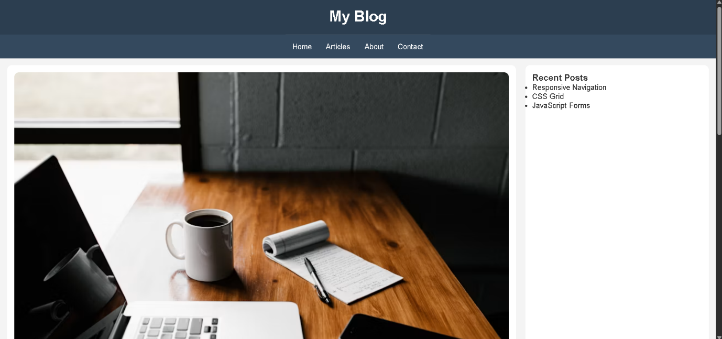

Result
A mobile-first blog layout was designed using CSS Flexbox and media queries. The layout begins with a single-column mobile design and scales effectively for tablets and desktops, ensuring good accessibility, readability, and responsiveness.

Question 5: JavaScript Event Handling for Dynamic Menu - Marks(4)
Suppose that a website includes a dynamic menu that responds to user interactions.
(a) Identify appropriate JavaScript events for menu interaction.
(b) Design event handling logic for menu toggle functionality.
(c) Implement interaction for user actions (click/hover).
(d) Evaluate performance and suggest improvements.

ANS:

JavaScript event handling for dynamic menu
(a) Identify appropriate JavaScript events for menu interaction
A dynamic menu responds to user actions using JavaScript events. The most suitable events are:
- click – opens or closes the menu.
- mouseover – displays submenu on hover.
- mouseout – hides submenu when the cursor leaves.
- mouseenter – triggers when the pointer enters the menu.
- mouseleave – triggers when the pointer exits the menu.
For mobile devices, the click event is the most commonly used for menu toggling.
(b) Design event handling logic for menu toggle functionality
The menu toggle logic works as follows:
- The user clicks the hamburger icon.
- JavaScript detects the click event.
- A CSS class (for example, show) is added or removed.
- The menu becomes visible or hidden.
- The same button can open and close the menu repeatedly.
This approach is simple and efficient for responsive websites.
(c) Implement interaction for user actions (click/hover)
HTML (index.html)
<!DOCTYPE html>
<html>
<head>
<meta charset="UTF-8">
<meta name="viewport" content="width=device-width, initial-scale=1.0">
<title>Dynamic Menu</title>
<link rel="stylesheet" href="style.css">
</head>
<body>

<nav class="navbar">
<div class="logo">MySite</div>

<ul class="menu" id="menu">
<li><a href="#">Home</a></li>
<li><a href="#">About</a></li>
<li><a href="#">Services</a></li>
<li><a href="#">Contact</a></li>
</ul>

<div class="hamburger" id="toggleBtn">
☰
</div>
</nav>

<script src="script.js"></script>

</body>
</html>
CSS (style.css)
*{
margin:0;
padding:0;
box-sizing:border-box;
}

body{
font-family:Arial, sans-serif;
}

.navbar{
display:flex;
justify-content:space-between;
align-items:center;
background:#333;
padding:15px 20px;
color:white;
}

.logo{
font-size:22px;
font-weight:bold;
}

.menu{
display:flex;
list-style:none;
gap:20px;
}

.menu a{
color:white;
text-decoration:none;
padding:8px;
}

.menu a:hover{
background:#555;
border-radius:5px;
}

.hamburger{
display:none;
font-size:28px;
cursor:pointer;
}

@media (max-width:768px){

.menu{
display:none;
flex-direction:column;
position:absolute;
top:60px;
left:0;
width:100%;
background:#444;
padding:20px;
}

.menu.show{
display:flex;
}

.hamburger{
display:block;
}

}
JavaScript (script.js)
const toggleBtn = document.getElementById("toggleBtn");
const menu = document.getElementById("menu");

toggleBtn.addEventListener("click", function(){

menu.classList.toggle("show");

});

const links = document.querySelectorAll(".menu a");

links.forEach(function(link){
link.addEventListener("mouseover", function(){
link.style.color = "yellow";
});
link.addEventListener("mouseout", function(){
link.style.color = "white";
});

});
OUTPUT:

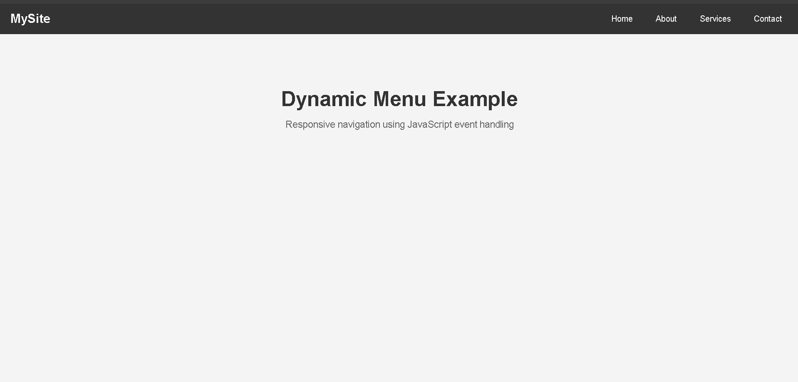
(d) Evaluate performance and suggest improvements
Advantages
- Simple and responsive.
- Fast menu interaction.
- Works well on mobile and desktop.
- Easy to maintain.
Performance considerations
- Use event delegation for large menus.
- Avoid attaching unnecessary event listeners.
- Minimize DOM manipulation.
- Use CSS transitions for smooth animations.
Suggested improvements
- Add keyboard navigation support.
- Close the menu when clicking outside.
- Add smooth slide-down animations.
- Improve accessibility using ARIA attributes.
- Optimize touch interactions for mobile devices.
Result
A dynamic responsive menu was implemented using JavaScript event handling. The menu responds to click and hover events, provides responsive behavior for mobile devices, and can be further enhanced with accessibility and animation improvements.

Code of Conduct:

I B. Sai Manoj Kumar (192411251) (Name / Reg No) certify that this submission is my original work and that I have adhered to the guidelines specified for this assessment. I understand that any violation of academic integrity rules will result in disciplinary action.

Signature of the student: B. Sai Manoj Kumar

RUBRICS FOR CALCULATION:

Criteria | Weightage (%) | Level 4 – Exemplary (4) | Level 3 – Proficient (3) | Level 2 – Developing (2) | Level 1 – Beginning (1)
Understanding of Concept | 25 | Demonstrates complete understanding of design requirements and concepts | Good understanding with minor gaps | Basic understanding with some errors | Poor understanding or incorrect concepts
Design / Implementation | 30 | Well-structured, efficient, and responsive design implementation | Correct implementation with minor issues | Basic implementation with inconsistencies | Incorrect or incomplete implementation
Use of Tools (CSS/JS) | 20 | Effective and advanced use of tools/techniques | Appropriate use of tools | Limited or inconsistent use | Incorrect or minimal use
Analysis & Evaluation | 15 | Insightful analysis with strong justification and optimization | Good analysis with justification | Basic analysis with limited depth | Poor or no analysis
Documentation / Clarity | 10 | Clear, well-structured, and properly presented solution | Mostly clear with minor issues | Basic clarity, missing details | Poor or unclear documentation

